DISPOSAL REQUIREMENTS
FOR GLASS BOXES
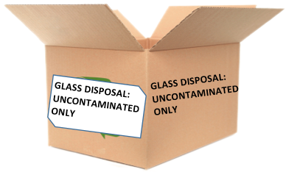
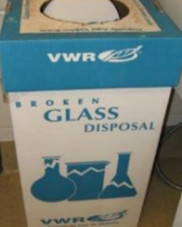

- For clean glass items and clean broken glass:
vials, beakers, Pasteur pipettes, tubes, etc.

- NO liquids (glass can be wet but contain no liquid)

- NO biological agents

- NO chemical residues/ precipitates/ sludges, etc.
(Glass items that once contained acetone, ethanol or
other evaporative solvent are O.K. for the glass box)

- NO sharps like needles, blades, etc.

- Broken glass: If in shards that could easily pierce
a cardboard box, then discard in an impervious
chemical sharps container or chemical waste bucket.

- Always line a glass collection box with a plastic
trash can liner---NOT A CHEMICAL BLUE BAG.

- Do not overfill.

- When full, close the box, seal it securely with tape
and discard it in the dumpster with care so that the box doesn’t break open & disperse sharp glass.

